BCSE497J - Project-I

Intelligent Investigative Interview Assistant Using Speech Emotion Analysis, Computer Vision and Large Language Models

23BCE2201 | AJMAL SADHIQ
23BCE2216 | GARVIT KOHLI
23BCE2221 | ANIKET AGRAWAL

Under the Supervision of

Dr.Sivaprakash S

Associate Professor Grade 1
School of Computer Science and Engineering (SCOPE)

B.Tech.
in
Computer Science and Engineering

School of Computer Science and Engineering



September 2026

ABSTRACT
Investigative interviews require an investigator to listen carefully, document responses, identify missing information, and decide appropriate follow-up questions. Performing these activities simultaneously can increase workload and lead to incomplete records or inconsistent questioning. This project proposes an Intelligent Investigative Interview Assistant that combines computer vision, speech processing, and large language models to support interview documentation and human controlled questioning.
The system is designed to organise interview information, produce transcripts, record observable facial activity, and generate context aware follow-up questions. It supports selection of major Indian and foreign languages and aims to preserve the original language of interview responses. The current prototype includes consent-based camera and microphone access, browser-supported speech recognition, manual transcript entry, local facial-movement analysis, and language-model integration for question and report generation. Facial-expression estimates are derived from heuristic combinations of facial movements and are not treated as verified measurements of a person’s internal emotional state. Dedicated speech-emotion recognition and validated multimodal behavioural analysis remain planned extensions.
The application uses a React frontend, a FastAPI backend, and a relational database. Its reporting structure separates recorded observations, tentative interpretations, recommendations, and limitations. The project aims to improve the organisation and reviewability of interview records while maintaining investigator control. It does not determine deception, guilt, innocence, or truthfulness. Evaluation is planned around transcription quality, question relevance, report faithfulness, usability, and performance across languages and recording conditions.

Keywords: Investigative Interview Assistant, Computer Vision, Speech Processing, Speech Emotion Analysis, Large Language Models, Multilingual Transcription, Human-in-the-Loop, Decision Support.

TABLE OF CONTENTS

Sl.No | Contents | Page No.
 | ABSTRACT | i
1. | INTRODUCTION | 1
 | 1.1 BACKGROUND | 1
 | 1.2 MOTIVATIONS | 1
 | 1.3 SCOPE OF THE PROJECT | 2
2. | PROJECT DESCRIPTION AND GOALS
 | 2.1 Literature Review
 | 2.2 Research Gap
 | 2.3 Objectives
 | 2.4 Problem Statement
 | 2.5 Project Plan
3. | TECHNICAL SPECIFICATION
 | 3.1 Requirements
 | 3.1.1 Functional
 | 3.1.2 Non-Functional
 | 3.2 Feasibility Study
 | 3.2.1 Technical Feasibility
 | 3.2.2 Economic Feasibility
 | 3.2.2 Social Feasibility
 | 3.3 System Specification
 | 3.3.1 Hardware Specification
 | 3.3.2 Software Specification
4. | DESIGN APPROACH AND DETAILS
 | 4.1 System Architecture
 | 4.2 Design
 | 4.2.1 Data Flow Diagram
 | 4.2.2 Use Case Diagram
5. | REFERENCES

1. INTRODUCTION

1.1 Background
Investigative interviews are used to collect accounts of events, clarify circumstances, and identify information requiring further examination. During an interview, the investigator must manage questioning, understand responses, observe the interaction, and maintain an accurate record. These responsibilities become more demanding when interviews are lengthy or involve different languages.
Developments in computer vision, automatic speech recognition, and natural language processing provide opportunities to support parts of this workflow. Speech recognition can assist transcription, computer vision can describe visible facial movements, and large language models can organise information and suggest follow-up questions.
However, observable behaviour does not provide a direct or dependable measurement of truthfulness. Facial movements, pauses, and changes in speech can have multiple explanations, including language difficulty, fatigue, discomfort, or the interview environment. Automated interpretations must therefore remain uncertain and open to human review.
This project develops an investigative interview assistant that brings interview records, transcription, facial observations, and conversational assistance into one application. Its purpose is to support documentation and information gathering while preserving the investigator’s responsibility for decisions.

1.2 Motivation
The project is motivated by the practical difficulty of conducting an interview while simultaneously maintaining detailed records and planning suitable follow-up questions. Manual notetaking may interrupt the conversation, and reviewing long recordings can require substantial time. A structured digital assistant could make important statements and unresolved details easier to locate.
Another motivation is multilingual accessibility. In India, interviews may involve different languages, accents, dialects, and combinations of languages. Preserving the interviewee’s original wording and identifying transcription uncertainty are important design goals.
The project also responds to the need for explainable assistance. An investigator should be able to understand why a question was suggested and distinguish recorded information from an automated interpretation. A useful assistant should organise available information without presenting unsupported conclusions as facts.
These considerations motivate a platform that combines consent-based capture, transcript management, neutral follow-up questions, and structured reporting. The intended benefit is improved organisation and reviewability of interview information, subject to evaluation rather than assumed improvement.

1.3 Scope of the Project
The project covers the design and development of a browser-based investigative interview assistant for controlled academic demonstrations. Its scope includes interview creation, participant information, consent recording, session controls, speech transcription, manual text entry, facial-movement observations, follow-up question generation, and structured reports.
The current implementation contains browser-supported speech recognition, local facial-landmark processing, heuristic expression estimates, database storage, and configurable language-model integration. Major Indian- and foreign- language options are available in the interface, although recognition and generation quality require separate evaluation for each language.
The proposed extended system includes dedicated speech-emotion analysis, reliable response-latency measurement, behavioural baselines, and explainable multimodal integration. These capabilities require additional implementation and validation.
The project excludes automated determinations of deception, guilt, innocence, or credibility. It also excludes autonomous interviewing without investigator supervision. Raw audio and video storage is not implemented in the current workflow. Operational deployment, forensic validation, and integration with official law-enforcement databases are outside the current scope.

2. PROJECT DESCRIPTION AND GOALS
The Intelligent Investigative Interview Assistant is a decision-support application that helps organise information before, during, and after an interview. It provides a shared workflow for collecting participant details, recording responses, reviewing observations, suggesting questions, and preparing a report.
The application treats the transcript as the main source for conversational assistance. Facial observations provide supplementary descriptions of visible movements and must not be used to establish the truth of a statement. Generated questions and reports remain subject to investigator review.

2.1 Literature Review
2.1.1 INTU-AI: Digitalization of Police Interrogation Supported by Artificial Intelligence
Garcia et al. present INTU-AI, a system that combines interview administration with facial-expression recognition, speech-emotion recognition, and text-based emotion analysis. The work demonstrates that interview documentation and multiple analysis modules can be brought into one decision-support application.
Its relevance to this project is the integration of administrative tasks and multimodal processing. However, the reported system does not establish the effectiveness of the specific Indian-language, neutral-questioning workflow proposed here. This project therefore focuses on transcript-grounded assistance, visible uncertainty, and investigator review as design requirements requiring their own evaluation. [1]

2.1.2 Detecting Lies in Investigative Interviews Through the Analysis of Response Latencies and Error Rates to Unexpected Questions
Melis et al. investigate response latency and response errors in an experimental identity-deception task. Participants answered control, expected, and unexpected questions, allowing the researchers to examine differences in response patterns.
The study motivates recording response timing alongside question context. Its controlled experimental setting, however, does not justify treating delayed responses in ordinary interviews as evidence of deception. For the proposed assistant, response latency is a contextual measurement that may indicate a need for clarification. It is not a classification rule for truthfulness. [2]

2.1.3 LAPIS: Language Model-Augmented Police Investigation System
Kim et al. introduce LAPIS, a language-model based system designed to provide investigation-related legal guidance. It combines specialised training data with retrieval from a relevant knowledge base.
The work illustrates the value of task-specific context and domain-focused information when using language models for investigative support. Its main task is legal reasoning rather than live interview transcription or facial analysis. The present project applies contextual language generation to a different task: suggesting neutral questions and organising interview records. LAPIS does not establish the reliability of those proposed functions. [3]

2.1.4 A Deception Detection Model by Using Integrated LLM with Emotion Features
Zhou et al. propose LieXBerta, which extracts text-based emotional features using RoBERTa and combines them with facial and action features in an XGBoost classifier.
The study provides an example of combining different feature sources. Its objective is deception classification, whereas the proposed assistant focuses on documentation and human-reviewed questioning. The reported classification findings cannot be transferred to this project, which uses different components and has no validated deception-classification function. The relevant design lesson is to preserve feature provenance and evaluate each modality before drawing conclusions from their combination. [4]

2.1.5 Introducing Representations of Facial Affect in Automated Multimodal Deception Detection
Mathur and Matarić examine continuous facial-affect representations, including valence and arousal, alongside visual, vocal, and verbal features. Their work explores how facial-affect features contribute to models evaluated on courtroom video data.
The paper motivates studying facial information over time rather than relying on isolated expression labels. However, its trained models differ from the current prototype’s heuristic facial-movement interpretation. Consequently, its results do not validate the prototype’s expression scores. The proposed assistant records visible cues and explicitly distinguishes these cues from uncertain interpretations. [5]
2.1.6 Towards AI-Driven Policing: Interdisciplinary Knowledge Discovery from Police Body-Worn Camera Footage
Srbinovska et al. propose a framework for analysing police body-worn camera footage using video, audio, and natural language processing. The work examines interaction patterns such as respect, escalation, and de-escalation.
Its relevance is the organisation of multimodal information around an interaction. However, body-worn camera footage differs from a structured interview in camera position, movement, noise, and conversational organisation. The present project uses a controlled interview workflow and focuses on transcripts, suggested questions, and reports. Findings from body-camera analysis require separate validation before application to this setting. [6]

2.1.7 Deception Detection in Videos
Wu et al. investigate visual, audio, and textual information for automated deception detection in videos. Their approach includes motion-related visual features, predicted micro-expressions, and acoustic features.
The study demonstrates an approach to comparing and combining modalities. Its task and evaluation data, however, differ from those of a live interview assistant. The proposed project draws on the general idea of modular feature processing but does not adopt a deception classifier. Its evaluation should measure transcription quality, question usefulness, and report faithfulness independently. [7]

2.1.8 Hidden in Plain Sight: Evaluation of the Deception Detection Capabilities of LLMs in Multimodal Settings
Miah et al. evaluate language and multimodal models across several deception-related datasets. They examine different prompting and training approaches and report limitations in the use of multimodal cues.
The study is relevant because it shows that a capable language model does not automatically provide dependable behavioural interpretation. For the proposed assistant, generated explanations must be checked against source records, and adding visual observations must not be assumed to improve reliability. Questions and report statements should be evaluated for grounding, relevance, and unsupported inference. [8]

2.1.9 LegalEye: Multimodal Court Deception Detection Across Multiple Languages
Baldivas et al. present LegalEye, which combines audio, visual, and textual information from courtroom material in English, Spanish, and Tagalog. The work addresses multilingual modelling and discusses limitations associated with its data and labels.
The paper supports the need to evaluate systems across languages rather than assuming that performance transfers between them. Its language coverage does not establish performance for Indian languages. In this project, multilingual interface support is therefore distinguished from demonstrated recognition or generation accuracy. Evaluation must account for language, accent, code-switching, and recording quality. [9]

2.1.10 DecepBench: Benchmarking Multimodal Deception Detection
Braverman et al. introduce DecepBench, extending the DOLOS game-show dataset with transcripts and examining multimodal features through interpretable analyses.
The work highlights the importance of benchmarks and explicit evaluation procedures. However, game-show interactions are different from investigative interviews. Performance on such data cannot establish operational suitability for this project. The proposed assistant requires task-specific evaluation using consented interview scenarios, human-reviewed transcripts, and assessments of question quality and report accuracy. [10]
2.1.11 MELD: A Multimodal Multi-Party Dataset for Emotion Recognition in Conversations
Poria et al. introduce MELD, a dataset containing textual, audio, and visual information for conversational emotion recognition. The work emphasises the importance of conversational context and information from multiple speakers.
MELD is relevant to future experiments involving speech and conversational emotion modelling. However, its dialogue setting differs from investigative interviews and does not directly represent the intended Indian-language use cases. It may support preliminary research, but application-specific evaluation would still be required. The current prototype does not claim to have been trained or evaluated on MELD. [11]

2.1.12 Learning Modality-Specific Representations with Self-Supervised Multi-Task Learning for Multimodal Sentiment Analysis
Yu et al. propose a method that learns modality-specific representations alongside a multimodal sentiment task. Their approach considers information that may be lost when different modalities are combined without preserving their individual contributions.
The work informs the proposed design principle of retaining separate visual, acoustic, and textual observations before integration. However, sentiment analysis differs from investigative interviewing, and the published model is not implemented in the current prototype. Its relevance is architectural: future fusion should preserve modality-specific information and be evaluated against individual-modality baselines. [12]

Literature Review Findings
The reviewed works provide foundations for multimodal processing, conversational analysis, domain-specific language models, and systematic evaluation. They also reveal substantial differences in datasets, tasks, and definitions of success.
For this project, the main lesson is that integration alone does not establish reliability. Each component requires appropriate evaluation, and the final application must preserve the distinction between source information, uncertain interpretation, and recommended action.

2.2 Research Gap
The research gap addressed by this project is an application and evaluation gap: developing a reviewable interview workflow that combines language assistance and observable information while maintaining clear limits on automated interpretation.

1. Integration around the interview workflow
The reviewed literature includes multimodal systems, legal assistants, and classification models. The proposed project focuses on coordinating intake, consent, live transcript handling, question suggestions, and reporting within one workflow.

2. Transcript-grounded adaptive questioning
A useful interview assistant must respond to the information already provided and identify unresolved details. It should avoid repeating answered questions or introducing unsupported assumptions. This behaviour needs evaluation beyond checking whether a model produces grammatically correct text.

3. Indian-language evaluation
Available multilingual research does not establish performance across the Indian languages included in the proposed interface. Transcription, question generation, and report quality require language-specific assessment.

4. Separation of observation and interpretation
Visible facial movements and recorded statements should remain distinguishable from model-generated explanations. The system should preserve source information and communicate uncertainty rather than compressing everything into a single behavioural score.

5. Temporal organisation
Statements and observations should be organised by time so that investigators can review their sequence. Temporal co-occurrence must remain distinct from a causal relationship or a credibility judgement.

6. Practical failure handling
The application must remain usable when speech recognition, camera processing, or language-model services fail. Manual entry, clear error messages, and preservation of saved records are important requirements.

The project does not claim that all these capabilities are absent from existing systems. Its contribution is the proposed combination, implementation, and evaluation of these requirements within a controlled academic prototype.

2.3 Objectives

Primary Objective
To design and develop an investigative interview assistant that supports transcript management, observable facial-activity recording, neutral follow-up questioning, and structured reporting while retaining control to the investigator.
Specific Objectives
- Implement the interview lifecycle: Provide interview creation, start, pause, resume, and end functions during the prototype phase.
- Introduce consent-based capture: Require explicit consent before requesting camera and microphone access and display capture status throughout a session.
- Support transcript collection: Integrate browser-supported speech recognition and provide manual transcript entry when recognition is unavailable or inaccurate.
- Provide multilingual configuration: Include English and selected Indian- and Foreign-language options, with later evaluation of recognition and generation quality for each tested language.
- Record facial activity: Extract visible facial-movement features and display clearly labelled heuristic expression estimates without asserting internal emotional states.
- Generate contextual questions: Produce one suggested follow-up question per request, together with a reason and questioning strategy, using the available interview context.
- Reduce repeated questioning: Compare new suggestions with previous questions and evaluate their relevance and duplication rate.
- Generate structured reports: Organise output into observed information, interpretations, recommendations, and limitations.
- Define future speech and fusion modules: Specify interfaces and evaluation procedures for speech-emotion recognition, response timing, and multimodal integration.
- Evaluate the prototype: Before final project completion, assess functional behaviour, transcription quality, question usefulness, report faithfulness, and processing time using documented test scenarios.

2.4 Problem Statement

Traditional investigative interviews require investigators to manage questioning, document responses, observe the interaction, and identify information requiring clarification at the same time. This can create a substantial workload, particularly during lengthy or multilingual interviews.
The project addresses the need for an integrated assistant that organises interview information, supports transcription, records observable facial activity, and generates context-aware questions and reports. The system must preserve the source and uncertainty of its outputs so that recorded statements are not confused with automated interpretations.
The central problem is therefore to develop a practical, multilingual interview-support workflow that improves the accessibility and reviewability of information while avoiding unsupported behavioural conclusions and preserving human responsibility for all decisions.

2.5 Project Plan
The following is a proposed 16-week schedule. It represents planned sequencing rather than a record of completed dates.
Weeks 1–4: Problem Definition and Literature Review
Review relevant research, identify intended users, define project boundaries, and document the distinction between interview assistance and automated judgement. Refine the scope as requirements become clearer.
Weeks 3–6: Requirements and System Design
Prepare functional and non-functional requirements, system architecture, database entities, consent flow, and interview lifecycle. Refine the design alongside early application development.
Weeks 5–10: Core Application Development
Implement the frontend, backend, interview creation, participant intake, lifecycle controls, and persistent storage. Integrate these components with the speech and facial-processing workflows.
Weeks 7–12: Speech and Transcript Workflow
Integrate browser-supported speech recognition, language selection, manual text entry, and transcript display. Test microphone permission handling, recognition failures, and transcript storage.
Weeks 7–12: Facial-Activity Processing
Integrate facial landmarks and movement features, display heuristic expression estimates, and store timestamped observations. Test low-light conditions, missing-face scenarios, and integration with interview records.
Weeks 9–14: Conversational Assistance and Reporting
Integrate language-model generation, prior-question checks, and structured reports. Refine question relevance and report grounding while handling unavailable providers and insufficient input.
Weeks 11–16: Evaluation and Refinement
Evaluate transcription quality, question relevance, report faithfulness, processing time, and usability as modules become available. Document issues, improve the prototype, and repeat relevant tests after changes.
Weeks 3–16: Documentation and Review
Maintain requirements, design descriptions, implementation notes, and test records throughout development. Complete the report, presentation, demonstration procedure, and plan for subsequent speech-emotion and multimodal fusion work during the final weeks.
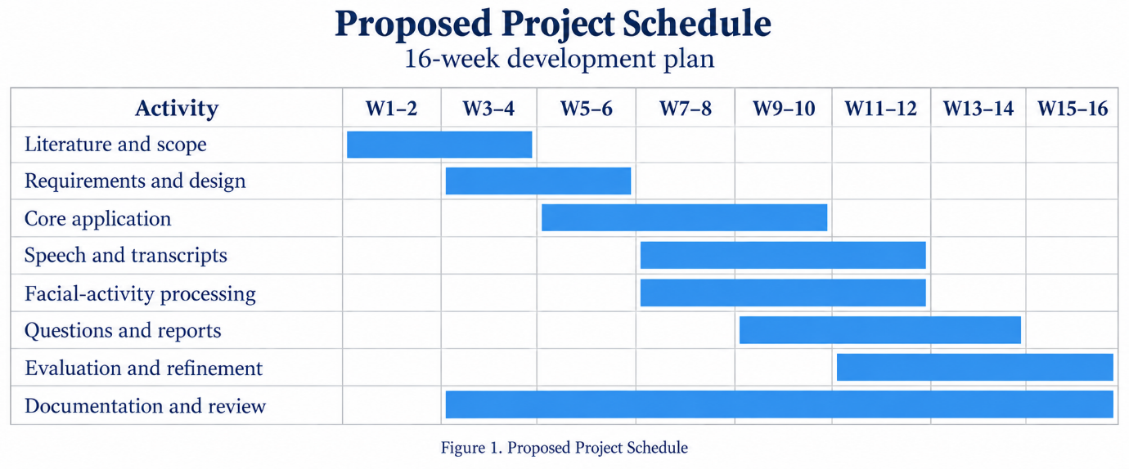
Fig. 1. Gantt chart
3. TECHNICAL SPECIFICATION

3.1 Requirements
Functional requirements describe what the application should do. Non-functional requirements describe the quality, reliability, and constraints expected of those functions.
Requirements below include the current prototype and the intended extended system. Planned functions are explicitly identified.

3.1.1 Functional
- Interview Creation: The system shall allow the investigator to create an interview with a title, objective, and selected language.
- Participant Intake: The system shall collect relevant participant information, including name, relationship to the event, and an initial statement. Optional personal information shall be limited to what the interview requires.
- Consent Recording: The system shall record explicit consent before initiating media capture. Consent status shall be associated with the interview record.
- Session Management: The system shall support starting, pausing, resuming, and ending an interview. The interface shall clearly display the current session state.
- Camera and Microphone Access: The system shall request browser permission for camera and microphone access and indicate when capture is active.
- Speech Transcription: The system shall display speech-recognition output when the browser supports it and saves the final transcript segments with speaker and language information.
- Manual Transcript Entry: The system shall provide a manual input path when speech recognition fails or requires correction. A future revision-history mechanism should preserve the original and corrected forms of edited records.
- Language Selection: The system shall provide language options including English, and various Indian languages. Language selection shall not be presented as proof of equal performance across languages.
- Facial-Activity Analysis: The system shall process camera frames to obtain facial-movement features and display heuristic expression estimates. These outputs shall be labelled as uncertain.
- Speech-Emotion Analysis (Planned): The extended system shall extract acoustic features and evaluate a speech-emotion model. Model identity, recording quality, and limitations shall accompany its output.
- Response-Latency Measurement (Planned): The system design shall support measuring the interval between the end of a question and the beginning of a response. Browser recognition delays shall be distinguished from actual response latency.
- Multimodal Integration (Planned): The extended system shall align textual, facial, acoustic, and timing information. Missing or low-quality modalities shall remain explicitly unavailable rather than being treated as neutral observations.
- Follow-Up Question Generation: The system shall generate a contextual question with an explanation of its purpose. The investigator shall decide whether to use the suggestion.
- Question Diversity: The question-generation workflow shall consider previous questions and attempt to avoid exact or closely repeated suggestions.
- Dashboard: The interface shall display session status, capture indicators, transcript segments, facial observations, and suggested questions.
- Report Generation: The system shall generate a report from available interview records, separating observations, interpretations, recommendations, and limitations.
- Persistent Storage: The system shall store interview details, transcripts, generated questions, events, observations, and reports in a relational database.
- Access Control: Before operational deployment, the system shall authenticate users and restrict access to authorised interview records. A database entity for investigators does not by itself satisfy this requirement.
- Raw-Media Handling: The current workflow shall not be described as storing raw audio or video. Any future media-storage feature shall require separate implementation and explicit user choice.
- Human Oversight: The system shall not produce automated decisions about deception, guilt, innocence, or truthfulness.

3.1.2 Non-Functional
- Performance: The interface should remain responsive while capturing input and requesting generated content. Transcription delay, facial-processing time, and language-model latency should be measured separately.
- Reliability: A failure in one component should not cause loss of previously saved interview records. Provider failures should produce clear messages and permit appropriate recovery.
- Usability: The interface should use understandable labels and clearly separate interview setup, active interviewing, and report review. Capture and session status should remain visible.
- Privacy: The application should minimise personal-data collection. The investigator should understand whether a configured speech or language-model service processes information externally.
- Security: Operational deployment requires authentication, authorisation, encrypted transport, protected credentials, and controlled retention. These are deployment requirements rather than claims of completed security hardening.
- Maintainability: The application should separate user interface logic, API handling, data models, and model-provider integrations so that components can be changed independently.
- Explainability: Generated questions should include a concise rationale. Interpretations should identify the information on which they depend and communicate uncertainty.
- Multilingual Quality: Quality should be evaluated separately for each tested language, accent group, and recording condition. Aggregate results should not conceal poorly performing groups.
- Accessibility: The workflow should support manual text input and readable controls. Participants who cannot use a particular input modality should not be assigned an adverse interpretation because of missing data.
- Data Integrity: Records should contain interview identifiers and timestamps. Future correction workflows should preserve a reviewable history instead of silently replacing original information.
- Scalability: The design should permit later migration from local SQLite storage to a server database. Concurrent-session capacity must be measured before supporting multiple simultaneous users.
- Reproducibility: Evaluation should record the software version, model configuration, browser, hardware, language, and test conditions.

3.2 Feasibility Study
3.2.1 Technical Feasibility
The core application is technically feasible using the technologies already present in the project. React supports the browser interface, FastAPI handles application requests, and SQLAlchemy provides relational data access.
The inspected implementation contains browser media capture, speech-recognition integration, MediaPipe facial-landmark processing, and language-model adapters for contextual generation. These establish an implementation basis, although code presence alone does not prove successful operation in every browser or provider configuration.
Several technical constraints remain:
- Speech recognition depends on browser support and service availability.
- Facial processing requires suitable camera input and successful model loading.
- Expression estimates use heuristic rules and require independent evaluation.
- Local language-model performance depends on available memory and processing resources.
- Remote generation depends on network access and provider availability.
- Dedicated speech-emotion recognition and validated multimodal fusion remain additional work.
A staged approach is therefore feasible: establish the interview workflow first, evaluate each analysis component separately, and integrate additional modalities only when their behaviour is understood.
3.2.2 Economic Feasibility
The prototype can use an existing laptop or desktop, webcam, and microphone. Its application frameworks and local database can be used without purchasing specialised interview hardware.
The main cost categories are development time, optional model-provider usage, computing resources, storage, and evaluation effort. Running a local language model may reduce external request costs but requires sufficient hardware. Remote generation reduces local inference requirements while introducing usage and connectivity costs.
The project avoids training large models from the beginning. Instead, it integrates existing components and concentrates development effort on workflow, data handling, and evaluation.
No numerical budget or return on investment is claimed because actual usage, hardware purchases, and deployment requirements have not been established. Economic evaluation should compare the cost of development and operation with measured changes in documentation time and reviewer effort.
3.2.3 Social Feasibility
Social feasibility depends on whether the system supports fair and understandable interviewing. Participants and investigators should be informed about capture, storage, and the limits of automated outputs.
The interface should avoid presenting facial movement, hesitation, or speech characteristics as proof of a hidden intention. Differences associated with language, disability, fatigue, culture, or recording conditions should be considered during evaluation.
The investigator remains responsible for questioning and reviewing reports. Suggested questions should encourage clarification without assuming wrongdoing or an expected answer.
The project has potential relevance to SDG 9 through software innovation and SDG 16 through its intended support for transparent documentation. These are intended areas of contribution, not demonstrated social outcomes. User acceptance and practical benefit require evaluation with appropriate supervision and consent.

3.3 System Specification
3.3.1 Hardware Specification
The following specifications are planning recommendations rather than measured minimum requirements.
- Processor: A modern multicore processor suitable for running the browser, frontend development server, and backend together.
- Memory: Approximately 8 GB RAM for a basic application demonstration using remote generation; 16 GB or more is preferable for development and some local-model configurations.
- Storage: SSD storage for source code, dependencies, and database files. Locally hosted models require additional space depending on model size.
- Camera: An integrated or external webcam with a clear, stable view of the participant’s face. A 720p camera is a reasonable starting point for evaluation.
- Microphone: An integrated or external microphone that captures intelligible speech. A headset or directional microphone can help control background noise during testing.
- Graphics Processing Unit: Not required for the basic application workflow. GPU acceleration may benefit local language models or future vision and speech models, depending on the selected implementation.
- Display: A display large enough to review the transcript, interview controls, and observations together.
- Network: Connectivity may be required for model-asset downloads, browser speech services, or remote language-model generation. The current application should not be assumed to operate entirely offline.
3.3.2 Software Specification
- Operating System: The current development environment is Windows. Other platforms may be supported after installation and browser compatibility checks.
- Programming Languages: Python is used for the backend, JavaScript and JSX for the frontend, and SQL through the database layer.
- Frontend: React provides interface components, while Vite supports frontend development and builds.
- Backend: FastAPI handles application requests. Pydantic supports request and data validation.
- Database: SQLite is the default local database. SQLAlchemy provides object-relational mapping. Alembic is included for database migration support.
- Browser Media Processing: Browser media APIs request camera and microphone access. Browser Speech Recognition APIs provide transcription where supported.
- Computer Vision: MediaPipe Tasks Vision provides facial landmarks and blendshape information. Application-defined rules convert these features into tentative expression labels.
- Language-Model Integration: The backend contains integrations for local Ollama generation and OpenAI generation. The active model depends on configuration and availability. No particular model’s quality is assumed without testing.
- Communication: HTTP APIs handle records and generation requests. WebSocket support is available for session event communication.
- Development and Verification: Git supports source control. Backend tests and frontend build checks support software verification. Live media behaviour and model quality require additional functional evaluation.
Planned Extensions: Dedicated speech-emotion models, improved speech-to-text alternatives, timing analysis, multimodal fusion, and production access controls remain areas for further development.

4. DESIGN APPROACH AND DETAILS

4.1 System Architecture
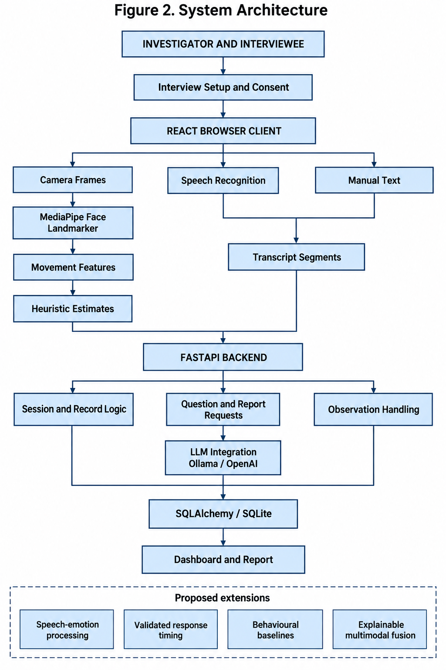

Fig. 2. System Architecture
The system follows a modular client–server architecture. The browser manages user interaction and media access. The backend manages interview records, generation requests, and database operations.
The current architecture separates two main paths:
- A transcript path for storing responses and generating questions.
- A facial-observation path for recording visible movements and including appropriately qualified observations in reports.
Dedicated speech-emotion processing and general multimodal fusion are proposed extensions.
4.1.1 Interview Setup and Consent
The investigator enters the interview title, objective, language, and participant information. The system records consent before requesting devices.
The initial statement is stored separately from statements collected during the live interview. This distinction helps prevent an earlier account from being treated as independently verified information.
4.1.2 Input and Transcription
The browser obtains camera and microphone access after permission is granted. Speech recognition produces interim and final text. Final segments are sent to the backend for storage.
Manual text entry provides an alternative when recognition is unavailable or inaccurate. The original language should be retained so that later review does not rely solely on translation.
4.1.3 Facial-Activity Processing
Camera frames are processed locally using MediaPipe facial landmarks and blendshape features. The application uses weighted combinations of movements to produce labels such as happiness-like or surprise-like expressions.
These labels are heuristic estimates. A displayed score represents the application’s rule output and must not be interpreted as a calibrated probability of an internal emotional state.
The system stores selected derived observations rather than raw video. Statements and observations can be associated by time, but temporal proximity does not establish why a movement occurred.
4.1.4 Speech-Emotion Processing — Proposed
A future speech module will examine features such as pitch variation, energy, speaking rate, and pauses. A selected model may then estimate vocal-affect categories.
Evaluation must distinguish speaker characteristics, recording noise, language, and conversational context. The module should report insufficient-quality input explicitly.
No speech-emotion accuracy is claimed for the present prototype.

4.1.5 Conversational Assistance
The question-generation component receives the objective, selected language, available statements, and previous questions. It requests one neutral follow-up question with a reason and strategy.
For example, if a statement is:
“I reached the building around 6 p.m. and saw someone leaving.”
A possible suggestion is:
“What did you notice about the person as they left?”
The question asks for missing observable detail without assuming identity or wrongdoing.
The current implementation includes duplicate checks and additional generation attempts. These mechanisms reduce some repetition but do not guarantee useful or non-leading questions. Investigator review remains necessary.
4.1.6 Dashboard and Reporting
The dashboard displays session controls, transcript segments, capture status, facial observations, and question suggestions.
Reports separate four categories:
- Observed: What was recorded or stated, with appropriate attribution.
- Interpreted: Tentative explanations or unresolved relationships.
- Recommended: Questions or review actions.
- Limitations: Missing information, processing uncertainty, and model constraints.
4.1.7 Database Layer
The database stores interview metadata and related records using interview identifiers. The model includes investigators, participant profiles, transcripts, questions, events, observations, and reports.
SQLite supports the local prototype. Moving to a server database would require deployment configuration, migration testing, backup procedures, and access-control implementation.

4.2 Design
The design follows four principles:
- Consent precedes capture.
- Source records remain distinguishable from generated content.
- Component failures remain visible.
- Investigators retain control over questions and conclusions.

4.2.1 Data Flow Diagram
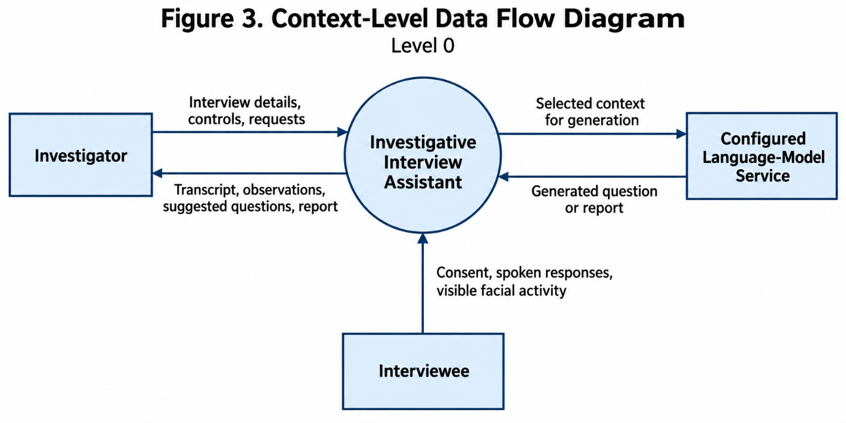
The investigator controls the application and receives its outputs. The interviewee supplies consent and responses. A configured language-model service processes the context supplied for generation.
Browser speech recognition may involve an additional external service, depending on the browser.

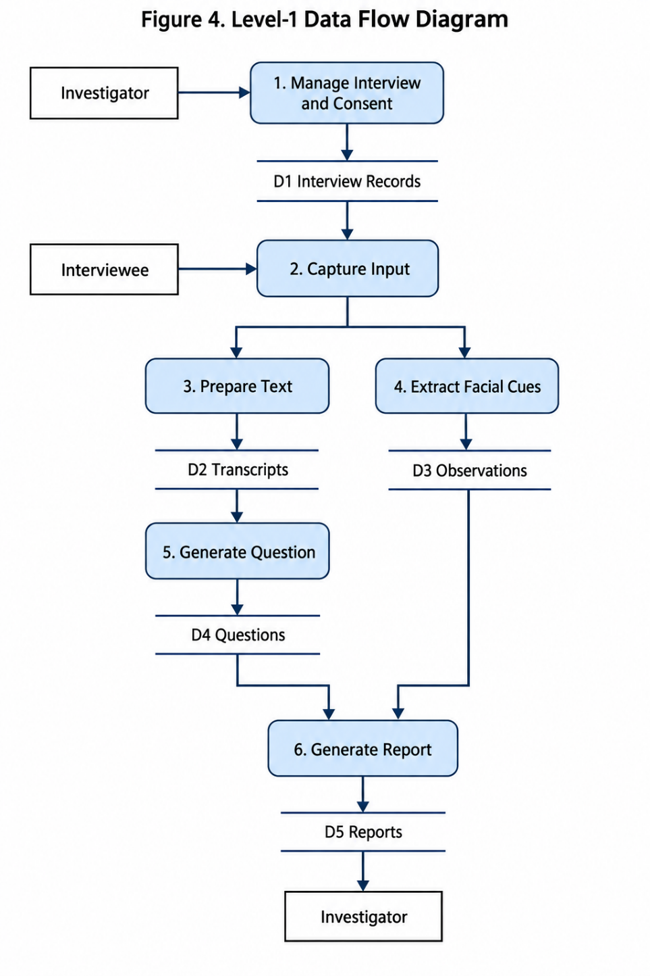
Process 1: Manage Interview and Consent
Validates setup information, records consent and maintains session state.
Process 2: Capture Input
Requests permitted devices and accepted interview input.
Process 3: Prepare Text
Receives recognised or manually entered text and saves final transcript segments.
Process 4: Extract Facial Cues
Processes facial movements and stores derived observations with timestamps and uncertainty.
Process 5: Generate Question
Uses the interview objective, statements, and earlier questions to request a follow-up suggestion.
Process 6: Generate Report
Combines available interview records into a structured, human-reviewable report.

4.2.2 Use Case Diagram
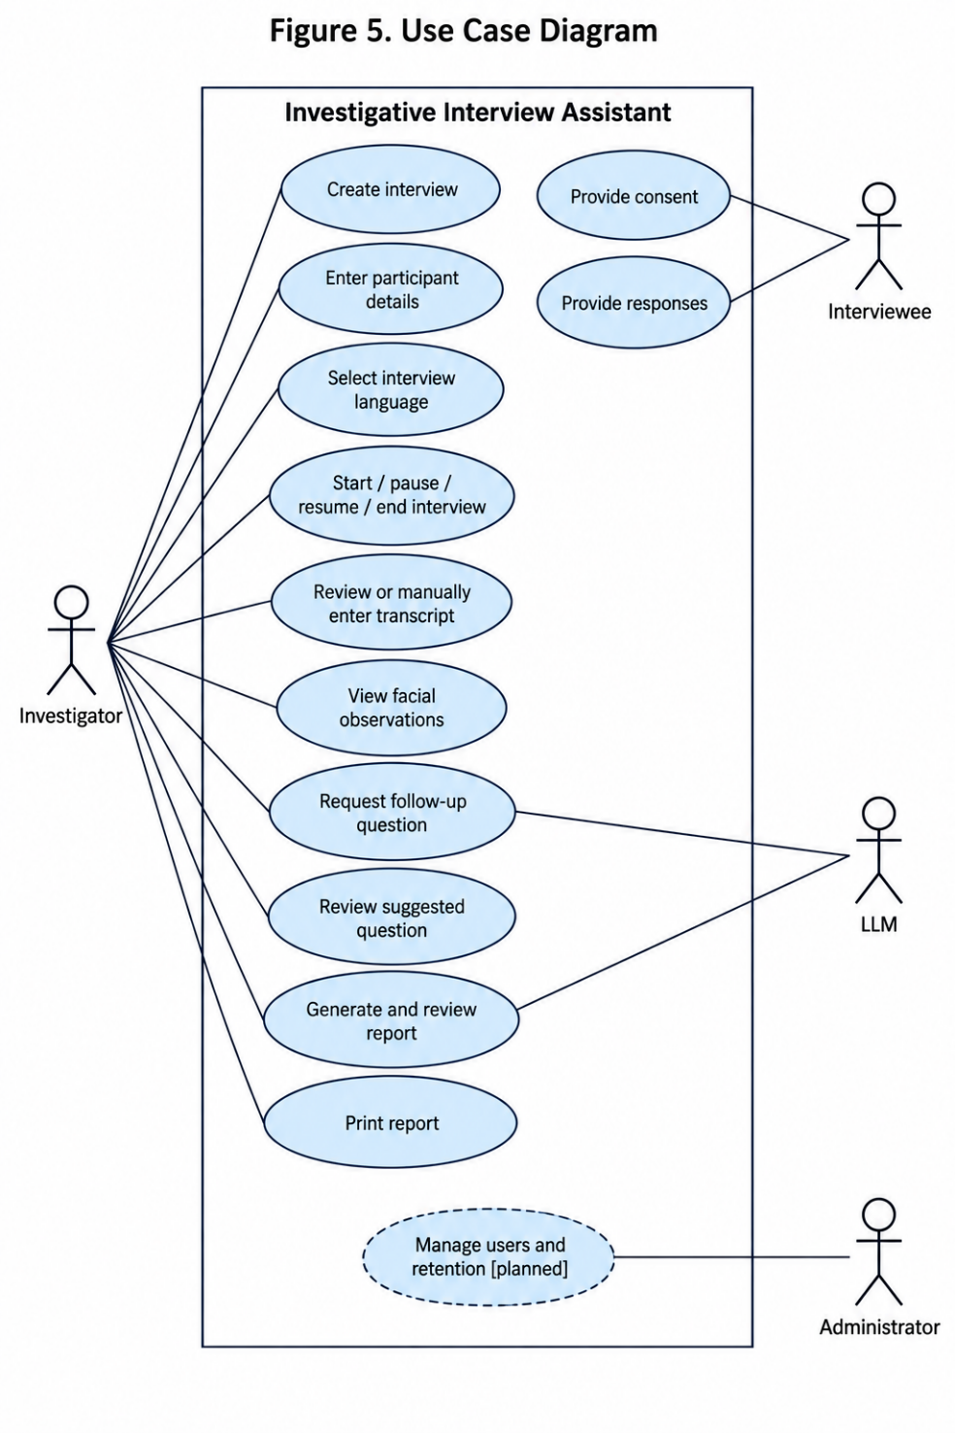
Use Case 1: Create Interview
- Precondition: The application is available.
- Main flow: The investigator enters the title, objective, language, and participant information. Required fields and consent are checked before an interview record is created.
- Postcondition: A new interview identifier is available.
Use Case 2: Start Interview
- Precondition: An interview exists and consent has been recorded.
- Main flow: The investigator starts the session. The browser requests device permissions, and the interface displays the resulting capture status.
- Alternative flow: If permission is denied or a device is unavailable, the application reports the problem. Manual text input remains an available alternative where supported.
Use Case 3: Generate Follow-Up Question
- Precondition: Relevant interview context is available, and the configured provider is reachable.
- Main flow: The investigator requests a question. The backend gathers context, requests structured output, checks repetition, and displays the suggestion with its reason.
- Postcondition: The investigator can review the question before using it.
Use Case 4: Generate Report
- Precondition: Saved transcript content is available; the interface enables reporting after the session ends.
- Main flow: The backend gathers records, requests a structured report, and returns the report with interview information and limitations.
- Alternative flow: Insufficient input or provider failure produces an error rather than a fabricated report.

5. REFERENCES
[1] J. P. Garcia, C. Grilo, P. Domingues, and R. Miragaia, “INTU-AI: Digitalization of police interrogation supported by artificial intelligence,” Applied Sciences, vol. 15, no. 19, Art. no. 10781, 2025, doi: 10.3390/app151910781.
[2] G. Melis, M. Ursino, C. Scarpazza, A. Zangrossi, and G. Sartori, “Detecting lies in investigative interviews through the analysis of response latencies and error rates to unexpected questions,” Scientific Reports, vol. 14, Art. no. 12268, 2024, doi: 10.1038/s41598-024-63156-y.
[3] H. Kim, D. Kim, J. Lee, C. Yoon, D. Choi, M. Gim, and J. Kang, “LAPIS: Language model-augmented police investigation system,” arXiv preprint arXiv:2407.20248, 2024.
[4] C. Zhou, Y. Zhang, C. Lin, and S. Zhou, “A deception detection model by using integrated LLM with emotion features,” Scientific Reports, vol. 15, Art. no. 32135, 2025, doi: 10.1038/s41598-025-17741-4.
[5] L. Mathur and M. J. Matarić, “Introducing representations of facial affect in automated multimodal deception detection,” arXiv preprint arXiv:2008.13369, 2020.
[6] A. Srbinovska, A. Srbinovska, V. Senthil, A. Martin, J. McCluskey, and E. Fokoué, “Towards AI-driven policing: Interdisciplinary knowledge discovery from police body-worn camera footage,” arXiv preprint arXiv:2504.20007, 2025.
[7] Z. Wu, B. Singh, L. S. Davis, and V. S. Subrahmanian, “Deception detection in videos,” in Proc. AAAI Conference on Artificial Intelligence, vol. 32, no. 1, pp. 1695–1702, 2018, doi: 10.1609/aaai.v32i1.11502.
[8] M. M. M. Miah, A. Anika, X. Shi, and R. Huang, “Hidden in plain sight: Evaluation of the deception detection capabilities of LLMs in multimodal settings,” in Proc. 63rd Annual Meeting of the Association for Computational Linguistics, vol. 1, pp. 31013–31034, 2025, doi: 10.18653/v1/2025.acl-long.1497.
[9] R. I. A. Baldivas et al., “LegalEye: Multimodal court deception detection across multiple languages,” Behavioral Sciences, vol. 15, no. 12, Art. no. 1707, 2025.
[10] E. Braverman et al., “DecepBench: Benchmarking multimodal deception detection,” in Proc. Third Workshop on Social Influence in Conversations, pp. 50–64, 2025, doi: 10.18653/v1/2025.sicon-1.3.
[11] S. Poria, D. Hazarika, N. Majumder, G. Naik, E. Cambria, and R. Mihalcea, “MELD: A multimodal multi-party dataset for emotion recognition in conversations,” in Proc. 57th Annual Meeting of the Association for Computational Linguistics, pp. 527–536, 2019, doi: 10.18653/v1/P19-1050.
[12] W. Yu, H. Xu, Z. Yuan, and J. Wu, “Learning modality-specific representations with self-supervised multi-task learning for multimodal sentiment analysis,” in Proc. AAAI Conference on Artificial Intelligence, vol. 35, no. 12, pp. 10790–10797, 2021.

